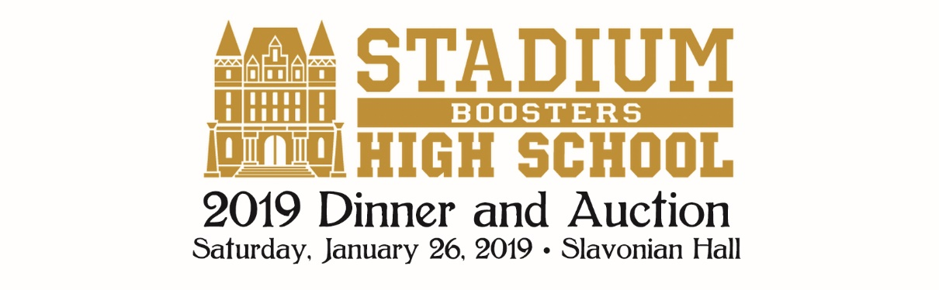
Sponsor Benefits

Presenting Sponsor $5,000
- Verbal recognition from the stage at the 2019 Auction, and at all football, basketball and volleyball games between January 1, 2019 and January 31, 2019
- Company logo on event materials*
- Full page ad in the auction program*
- Company logo in event PowerPoint
- Company logo on event Live Auction slides
- Name / Company logo on the stadiumboosters.org web site
- A named VIP table of eight at the 2019 Boosters Auction
- One additional Auction Table (8 complementary tickets) to the 2019 Auction
- Recognition in the post-event booster newsletter
- Social Media mentions

Lead Sponsor $2,500
- Verbal recognition from the stage at the 2019 Auction, and at all football, basketball and volleyball games between January 1, 2019 and January 31, 2019
- Company logo on event materials*
- Full page ad in the 2019 Auction program*
- Company logo in event PowerPoint
- Company logo on the stadiumboosters.org web site
- One Auction Table (8 complementary tickets) to the 2019 Auction
- Recognition in the post-event booster newsletter
- Social Media mentions

Table Sponsor $1,000
- Verbal recognition from the stage at the 2019 Auction
- 1/2 page ad in the 2019 Auction program*
- Name / Company in event PowerPoint*
- Name / Company listed on the stadiumboosters.org web site
- One Auction Table (8 complementary tickets) to the 2019 Auction
- Recognition in the post-event booster newsletter
- Social Media mentions

Supporting Sponsor $ 500
- Name / Company listed in the auction program*
- Name / Company listed on the stadiumboosters.org web site
- Two complementary tickets to the 2019 Auction
- Recognition in the post-event booster newsletter
- Social Media mentions

* Print deadline apply

